**Anaconda and Jupyter Notebook Setup Instructions**

1. Download and install Anaconda (Python 3.6 version, Graphical Installer). Anaconda is a special distribution of Python for scientific computing and data analysis – you’ll also get Jupyter (improved iPython notebooks) with this installation.

<https://www.continuum.io/downloads>

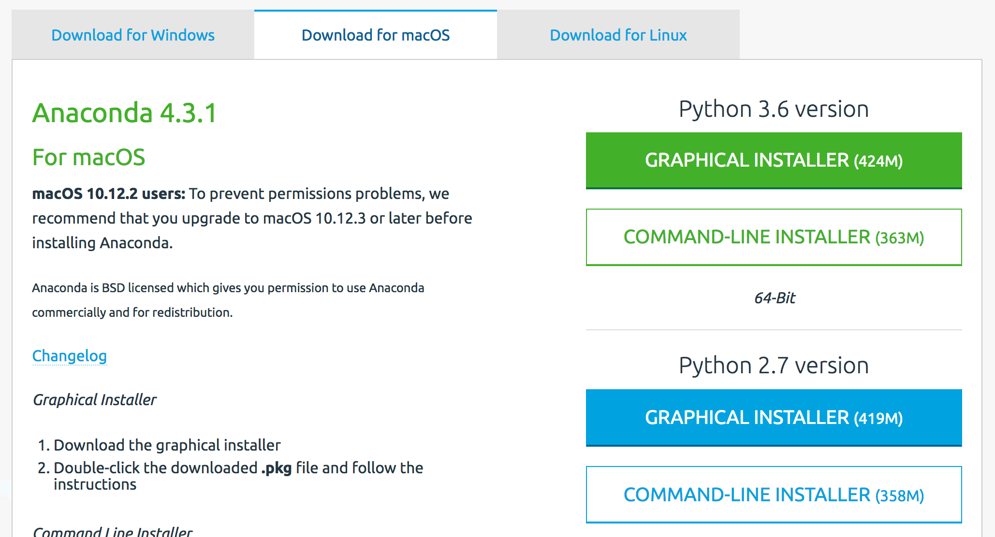

1. Open up a command prompt. Try to get familiar with the command prompt on your machine in general – it is very useful for all sorts of tasks when programming.

**MacOS**: Finder -> Applications -> Utilities -> Terminal

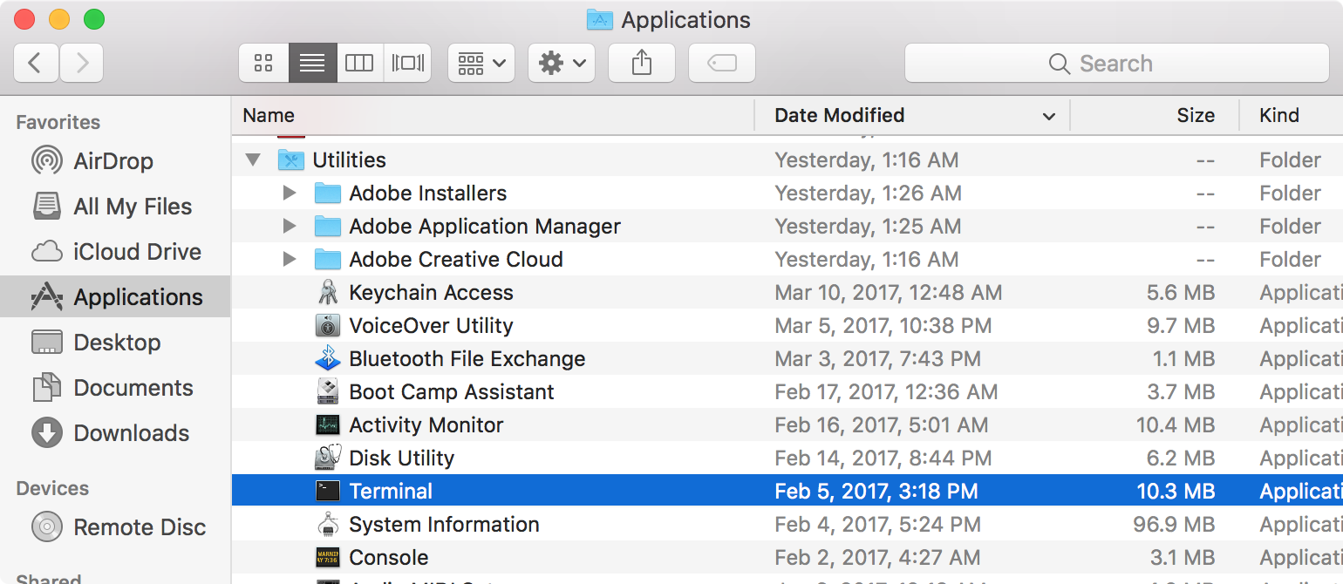

**Windows**: Start Menu -> Search -> “command prompt”

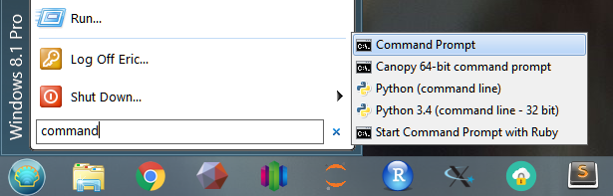

1. Check your Python version. Type python and run the command. This will open up a Python REPL (an interactive shell that shows Python input and output). If you installed Anaconda correctly, you should see “Python 3.6.x | Anaconda” in the command prompt.

Run some commands to see the REPL in action. Run the function quit() to exit Python and return to your command prompt.

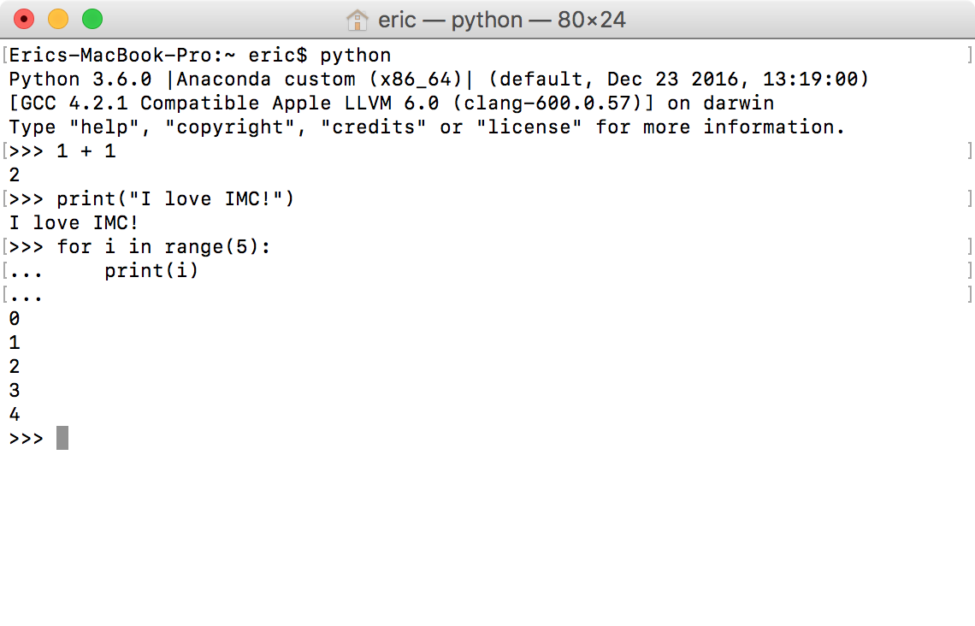

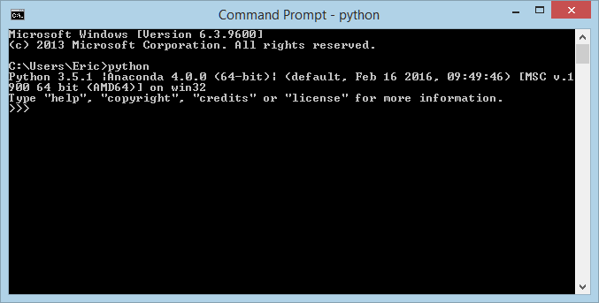

1. Run the Jupyter Notebook by running the command jupyter notebook.

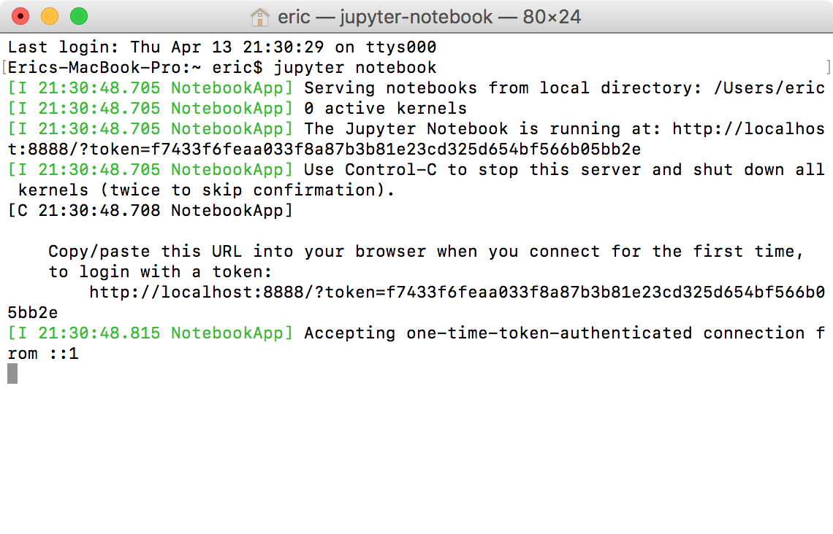

Jupyter is a web application that runs on your computer through a local web server, so this command will start up a web server and open up your default browser to the address: “localhost:8888.”

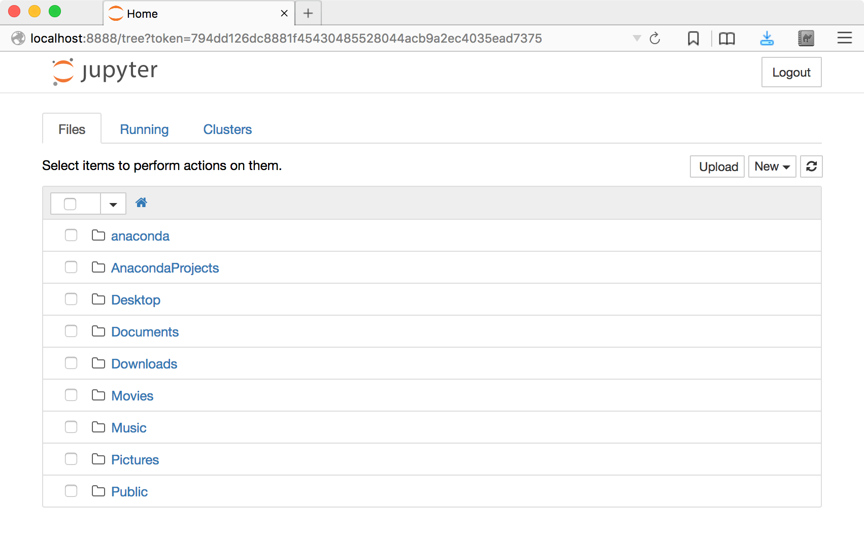

If nothing pops up or you close Jupyter out, you can open up a web browser and navigate to localhost:8888 to get back to Jupyter.

*Note that if you close your terminal, it kills the process and your Jupyter notebook as well.*

Use the Jupyter graphical interface to navigate to the sample notebook (Canvas -> Labs -> Lab 1 – Intro to Python -> sample.ipynb).

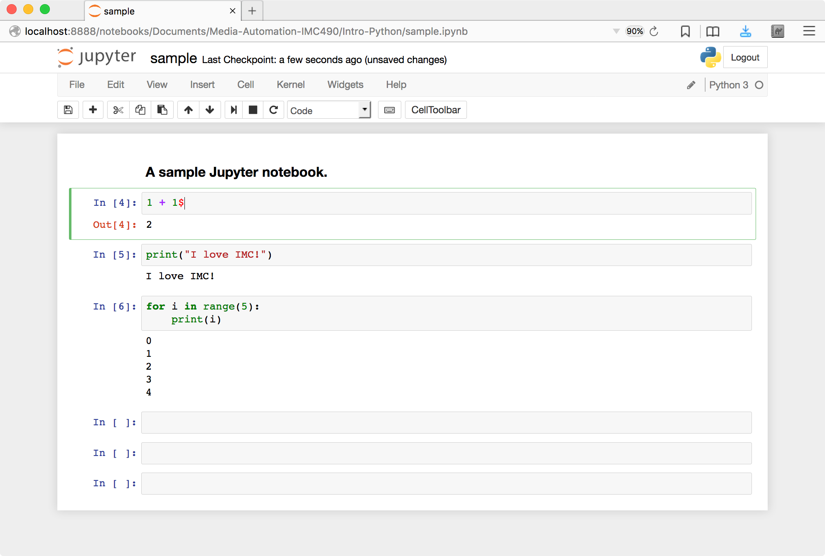

You’re all set up!